**Module 15)**

**HTML in Full Stack**

**1. HTML Basics**

**Theory Assignment**

**1) Define HTML. What is the purpose of HTML in web development?**

**HTML** stands for **HyperText Markup Language.** It is the main language used to **build the structure of a webpage.**

HTML is made of two parts:

* **HyperText**: It means linking one page to another using links. It helps users move from one page to another on a website.
* **Markup Language**: It means using special tags to organize and show text, images, videos, etc., in a proper layout on the web page.

### Purpose of HTML:

The main purpose of HTML is to:

* Create the **basic structure** of a webpage.
* Arrange content like **headings, text, images, and links** in a proper way.
* Make web pages **easy to read** for users and web browsers.

.

**2) Explain the basic structure of an HTML document. Identify the mandatory tags and their purposes.**

The **basic structure of an HTML document** includes some **important tags** that must be used to create any webpage. These tags help the browser understand and display the page properly.

**<!DOCTYPE> :** <!DOCTYPE> tells the browser which version of HTML is used; for example, <!DOCTYPE html> means HTML5 is being used.

**<html>** The <html> tag is the root of the HTML page and wraps all the content.

**<head>** Inside it, the <head> tag contains information about the page that is not shown on the screen, like the title, CSS, and scripts..

**<title> :** The <title> tag sets the title of the page, which is displayed in the browser tab.

**<body> :** The <body> tag contains everything that is visible on the webpage, such as headings, paragraphs, images, links, tables, and lists.

**3) What is the difference between block-level elements and inline elements in HTML? Provide examples of each.**

In HTML, elements are divided into two types: **block-level elements** and **inline elements**, based on how they appear and behave on a webpage.

* **Block-level elements**
* They **always start on a new line.**
* They take up the **full width** of the page (from left to right).
* They are used to create the **main sections** or layout of a webpage.
* **Tags:**
* <div>: A container used to group sections of content, useful for styling or scripting.
* <p>: Defines a paragraph. It adds space before and after by default.
* <h1> to <h6>: Heading tags, where <h1> is the largest/most important and <h6> is the smallest.
* <section>: Used to group related content like a topic or chapter.
* <article>: Represents independent content like a blog post or news article.
* <ul>: Creates an unordered (bulleted) list.
* <ol>: Creates an ordered (numbered) list.
* <li>: List item tag used inside <ul> or <ol> to define each item.
* **Inline elements**
* They **do not start on a new line**.
* They only take up the **space needed** for the content.
* They are used **inside block elements** to style or modify small parts of content.
* **Tags:**
* <span>: A simple inline container used to group text or elements for styling. It doesn't show any visible change by default.
* <a>: Creates a link to another page, section, or website.
* <img>: Used to show images. It is written as <img> and is a self-closing tag.
* <strong>: Makes text bold and shows importance.
* <em>: Emphasizes text and usually makes it italic.

Block-level elements define the overall structure of the page, while inline elements handle small pieces of content inside blocks without breaking the flow.

**4) Discuss the role of semantic HTML. Why is it important for accessibility and SEO?**

**Semantic HTML** means using HTML tags that clearly show the **meaning or role** of the content on a webpage.  
Instead of using general tags like <div> or <span>, we use specific tags like <header>, <footer>, <article>, and <nav> to show **what each part of the page is for**.

**Importance of Semantic HTML**

**1. Improves Accessibility:**  
Semantic tags help **screen readers** and other tools used by people with disabilities understand the webpage better.  
For example, <nav> tells the screen reader that this part is for **navigation**, and <main> shows the **main content**. This helps blind users know how the page is organized.

**2. Helps with SEO (Search Engine Optimization):**  
Search engines like Google use these tags to understand the content and its importance.  
For example, using the <article> tag for a blog post helps search engines know it’s a separate and valuable piece of content. This can help your website show up higher in search results.

**3. Cleaner and Easier Code for Developers:**  
Semantic HTML makes your code **easier to read and understand**. Other developers can quickly know what each section is for, which makes it easier to work together or make changes later.

**examples of semantic elements.**

|  |  |
| --- | --- |
| Element | Description |
| <header> | Represents the top section (logo, title, nav) |
| <footer> | Represents the bottom section (copyright) |
| <main> | Contains the primary content of the page |
| <nav> | Used for navigation links |
| <article> | Represents self-contained content |
| <section> | Groups related content together |
| <aside> | Side content like tips, ads or related links |

**(Lab Assignment Task )**

Create a simple HTML webpage that includes )

* A header (), footer (), main section (), and aside section ().
* A paragraph with some basic text.
* A list (both ordered and unordered).
* A link that opens in a new tab.

<!DOCTYPE html>

<html lang="en">

<head>

    <meta charset="UTF-8">

    <meta name="viewport" content="width=device-width, initial-scale=1.0">

    <title>Document</title>

</head>

<body>

    <header>

        <h1> My Semantic Webpage  </h1>

        <nav>

            <a href="#"> Home </a>

            <a href="#"> Contact </a>

        </nav>

    </header>

        <main>

            <section>

                <h3> Welcome!</h3>

                <p> This is a simple webpage that demonstrates semantic HTML elements and their use in web development.</p>

                <h4> Unordered List (Fruits) </h4>

                <ul>

                    <li> Apple </li>

                    <li> Banana </li>

                    <li> Mango </li>

                </ul>

                <h4> Ordered List (steps to study)</h4>

                <ol>

                    <li> Make a timetable </li>

                    <li> Read your notes </li>

                    <li> Practice questions </li>

                    <li> Revise regularly </li>

                </ol>

                <p> Visit <a href="https://www.w3schools.com/html/html5_semantic_elements.asp"> this link </a> to learn more.</p>

            </section>

        </main>

        <aside>

             <h4> Quick Tip </h4>

             <p> Use semantic tags to make your code easier to understand and improve your website's accessibility and SEO.</p>

        </aside>

        <footer> @2025 My Webpage. All rights reserved. </footer>

    </body>

</html>

**Output:**

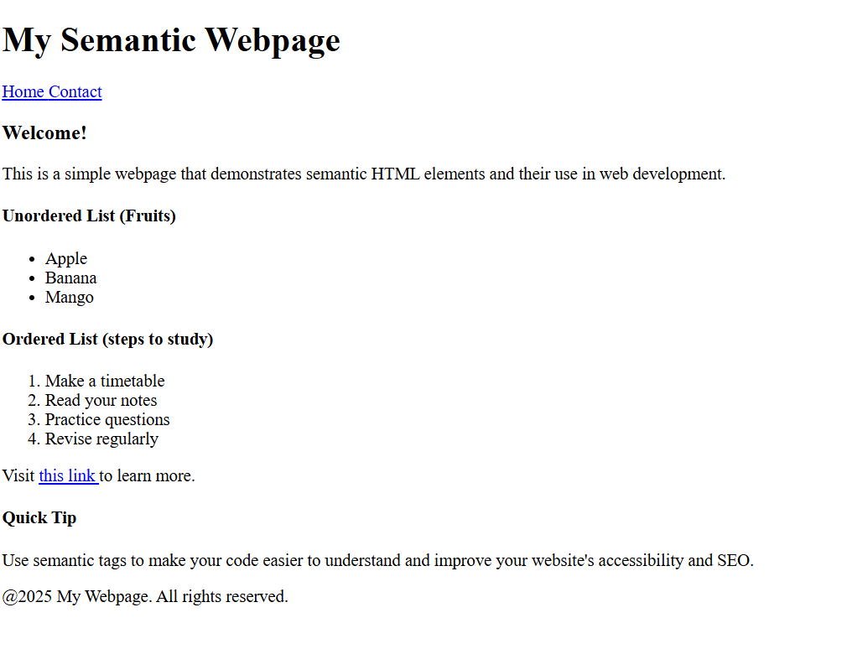

**2. HTML Forms Theory Assignment**

1. **What are HTML forms used for? Describe the purpose of the input, textarea, select, and button elements.**

**HTML forms** are used to **collect information from users** and send it to a server. They are commonly used on websites for things like:

* **User registration**
* **Login**
* **Sending feedback**
* **Searching something**
* **Placing orders online**

A form is made using the <form> tag, and inside it, we use different elements like text boxes, drop-down menus, checkboxes, and buttons to get input from the user.

* Common Form elements and their purpose:
* **<input>**

The <input> tag is used to take different types of user input such as text, password, email, number, checkbox, radio button, date, etc. For example, <input type="text"> is used for normal text input and <input type="password"> hides the text while typing.

<input type=”text” value=”name” placeholder=”Enter your name”>

* **<textarea>**

The <textarea> tag is used when users need to type a longer message like comments or feedback. It creates a large box where multiple lines of text can be entered.s messages or comments.

<textarea value=”message” name=”message” rows=”5” cols=”30”>Enter your message here…</textarea>

* **<select>**

The <select> tag is used to create a drop-down list where users can choose one or more options, and the list items are created using <option> tags.

<select name="country">

    <option> India </option>

    <option value="india"> USA </option>

    <option value="canada"> Canada </option>

    <option value="dubai"> Dubai </option>

</select>

* **<Button>**

The <button> tag creates a clickable button, which is usually used to submit the form or perform other actions like searching or resetting the form.

<button type="submit">

        submit

</button>

<input type="submit" value="submit">

HTML forms allow user interaction with a webpage by collecting data through various input types, which can then be processed or stored by a server.

1. **Explain the difference between the GET and POST methods in form submission. When should each be used?**

|  |  |
| --- | --- |
| GET Method | Post Method |
| GE.T method is used to request data from a specified resource. | POST method is used to send data to a server to create/update a resource. |
| The query string (name/value/pairs) is sent in the URL of a GET request | The data sent to the server with POST is stored in the request. |
| GET requests can be cached | POST requests are never cached |
| GET requests remain in the browser history | POST requests do not remain in the browser history |
| GET requests can be bookmarked | POST requests can not be bookmarked |
| GET requests should not be used when dealing with sensitive data (ex. Password) | POST requests have no restrictions on data length. |
| GET requests have length restrictions.  (due to URL length limits) | POST requests have no significant data length limit. |
| GET is used for retrieving data, not for modifying server state. | POST is used when data is submitted to change or update server state |
| Data is visible to everyone in the URL | Data is hidden from URL |
| GET is less secure because data appears in browser history and server logs. | POST is more secure as data is not stored in browser history or logs. |

**3) What is the purpose of the label element in a form, and how does it improve accessibility?**

The <label> element is used to give a **name or title** to form fields like <input>, <select>, or <textarea>. It tells users what information they need to type in each box. This makes the form **easier to understand** and more **user-friendly**, especially for people using screen readers or other assistive tools.

<label for="email"> Email: </label>

<input type=""email" id="email" name="email">

How it helps

* **Screen Reader Friendly:** Screen readers read the label aloud, so **visually impaired users** know what the field is for.
* **Easier to Click:** Clicking on the label will also select (focus) the input box, making it **easier for users** to fill the form.
* **Gives Clear Instructions:** Labels help users **understand what to enter**, which reduces mistakes.
* **Follows Accessibility Rules:** Using labels properly is part of **accessibility standards** (WCAG), which means your website will be better for all users.

(Lab Assignment Task )

Create a contact form with the following fields )

* Full name (text input)
* Email (email input)
* Phone number (tel input)
* Subject (dropdown menu)
* Message (textarea)
* Submit button Additional Requirements )
* Use appropriate form validation using required, minlength, maxlength, and pattern.
* Link form labels with their corresponding inputs using the for attribute.

<!DOCTYPE html>

<html lang="en">

<head>

    <meta charset="UTF-8">

    <meta name="viewport" content="width=device-width, initial-scale=1.0">

    <title>Contact Form</title>

</head>

<body>

        <form method="POST">

            <fieldset>

                <h4> Contact form </h4>

                <table>

                        <tr>

                            <td><label for="fullname"> Full Name:</label></td>

                            <td><input type="text" id="name" placeholder="Enter your full name" name="full name" required minlength="3" maxlength="50"/> </td>

                        </tr>

                        <tr>

                            <td><label for="email">Email: </label> </td>

                            <td><input type="email" id="email" placeholder="Enter your email id" name="email" required/> </td>

                        </tr>

                        <tr>

                            <td><label for="phone number"> Phone Number: </label> </td>

                            <td><input type="tel" id="contact" placeholder="Enter 10-Digit mobile number" name="Phone Number" required pattern="[0-9]{10}"/></label></td>

                        </tr>

                        <tr>

                            <td><label for="subject"> Subject: </label> </td>

                                    <td><select name="subject" required>

                                            <option> ----select----</option>

                                            <option id="maths"> Maths </option>

                                            <option id="bio"> Bio </option>

                                            <option id="commerce"> Commerce </option>

                                            <option id="art"> Art </option>

                                            <option id="agriculture"> Agriculture </option>

                                    </select>

                                    </td>

                        </tr>

                        <tr>

                            <td><label for="message"> Message: </label> </td>

                            <td><textarea id="message" name="message" placeholder="Enter your message here..."></textarea> </td>

                        </tr>

                        <tr>

                            <td><input type="submit" id="submit" value="submit"></td>

                        </tr>

                </table>

            </fieldset>

        </form>

</body>

</html>

Output:

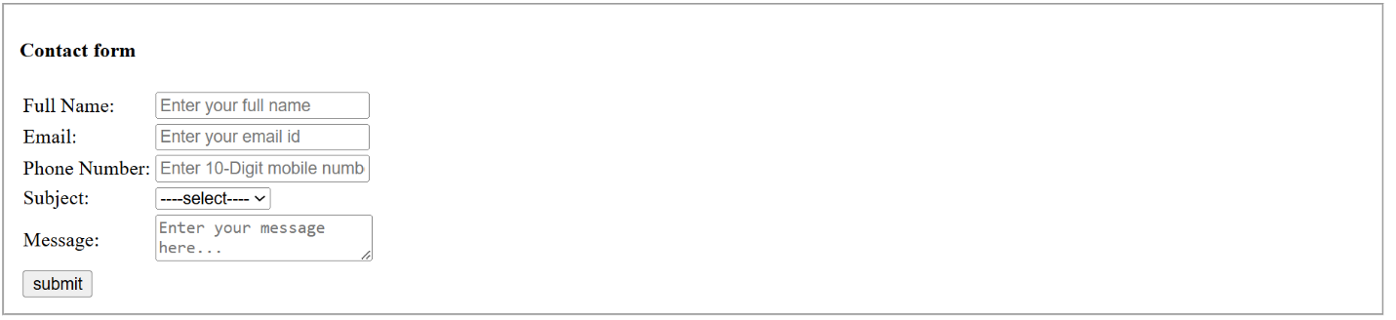

**3. HTML Tables**

**Theory Assignment**

1. **Explain the structure of an HTML table and the purpose of each of the following elements:**

**<table>, <tr>, <th>, <td> and <thead>.**

An **HTML table** is used to show data in the form of **rows and columns**, just like you see in Excel or spreadsheets.

**<table> :**The <table> tag is the **main container** for the table. It starts and ends the table and holds all the rows and cells inside it.

**<table>**

**(Tabular data)**

**</table>**

**<tr> (Table Row):** The <tr> tag is used to **create a row** in the table. It holds the cells (<td> or <th>) that are placed side by side in one row.

**<tr>**

**<td>Data 1</td>**

**<td>Data 2</td>**

**</tr>**

**<th> (Table Head):** The <th> tag is used to create a **heading cell** in a table. It’s usually placed in the first row or inside the <thead> tag. Text in <th> is **bold and centered** by default. It tells what each column means.

**<tr>**

**<th>Name</th>**

**<th>Age</th>**

**</tr>**

**<td> (Table Data Cell):** The <td> tag is used to create a **normal data cell** in a row. It holds the actual data of the table.

**<tr>**

**<td>John</td>**

**<td>25</td>**

**</tr>**

**<thead> (Table Head):** The <thead> tag is used to group the header section of the table. It usually contains the row with <th> elements. This tag helps in organizing the table better and is useful for styling and printing.

**<thead>**

**<tr>**

**<th>Name</th>**

**<th>Age</th>**

**</tr>**

**</thead>**

1. **What is the difference between colspan and rowspan in tables? Provide examples.**

In HTML tables, **colspan** and **rowspan** are used when you want a single cell to cover **more than one column or row**.

* **HTML Table- Colspan**

• Used to merge cells across rows (top to bottom**)**.

• It makes one cell stretch vertically over two or more rows.

• The number you give in rowspan shows how many rows it should cover.

* **HTML Table- Rowspan**

• Used to merge cells across rows (top to bottom).

• It makes one cell stretch vertically over two or more rows.

• The number you give in rowspan shows how many rows it should cover.

|  |  |  |  |
| --- | --- | --- | --- |
| Attribute | Span Across | Direction | Used in |
| colspan | Columns | Horizontal | <td>, <th> |
| rowspan | Rows | Vertical | <td>, <th> |

<html>

    <head>

            <title> Time table </title>

    </head>

    <body>

            <table border="5" align="center" cellpadding="5" cellspacing="0">

                <tr align="center">

                    <td colspan= "6"> Time Table </td>

                </tr>

                <tr>

                    <th rowspan ="6">  Hours </th>

                    <th> Mon </th>

                    <th> Tue </th>

                    <th> Wed  </th>

                    <th> Thu </th>

                    <th> Fri </th>

                <tr>

                    <td> Math </td>

                    <td> Science </td>

                    <td> Math </td>

                    <td> Science </td>

                    <td> Arts </td>

                </tr>

                <tr>

                    <td> Math </td>

                    <td> Science </td>

                    <td> Math </td>

                    <td> Science </td>

                    <td> Arts </td>

                </tr>

                <tr>

                    <td align="center" colspan="5"> Lunch </td>

                </tr>

                <tr>

                    <td> Math </td>

                    <td> Science </td>

                    <td> Math </td>

                    <td rowspan="2" colspan="2" align="center"> Project </td>

                </tr>

                <tr>

                    <td> Math </td>

                    <td> Science </td>

                    <td> Math </td>

                </tr>

            </table>

    </body>

</html>

Output:

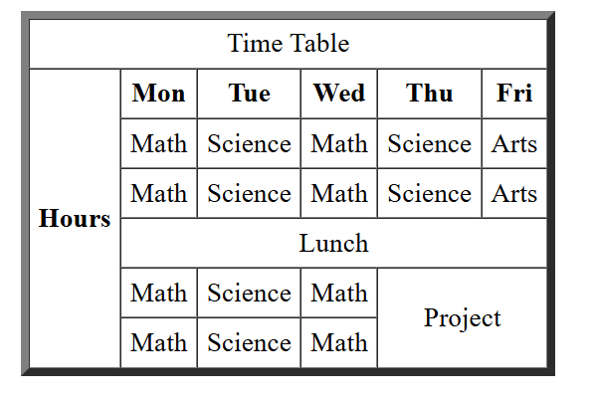

**3 ) Why should tables be used sparingly for layout purposes? What is a better alternative?**

Using HTML <table> tags to design the **layout of a webpage** (instead of just showing data) is **not a good idea** in modern web development.

**Problem with Using Tables for Layout:**

**• Not semantic:** Tables are made for showing data, not for page design. Using them wrongly can confuse screen readers and accessibility tools.

• **Hard for disabled users:** People using screen readers may find it difficult to understand the content when tables are used for layout instead of real data.

• **Difficult to edit:** When you use tables to design a webpage, it becomes hard to update or change the layout later, especially in big projects.

• **Not mobile-friendly:** Tables do not adjust well on small screens like phones, so the layout may break or look bad.

• **Messy code:** Table-based layouts need more complicated code, with many nested tags, which makes the HTML long and harder to fix.

* **For Better alternative: CSS (Cascading Style Sheets)**

Instead of using tables, we should use **CSS with <div> and semantic tags** like:

* <header> – for top section
* <section> – for grouped content
* <article> – for blog or news content
* <footer> – for the bottom of the page
* <main> – for the main content
* **CSS allows for:**
* It allows you to make **responsive designs** using media queries that work on all screen sizes.
* It keeps your code **clean and easy to manage**.
* It separates **content (HTML)** from **design (CSS),** making everything more organized.

**Lab Assignment Task :**

**1. Create a product catalog table that includes the following columns )**

* Product Name o Product Image (use placeholder image URLs)
* Price
* Description and Availability (in stock, out of stock) Additional Requirements )
* Use thead for the table header.
* Add a border and some basic styling using inline CSS.
* Use colspan or rowspan to merge cells where applicable.

<!DOCTYPE html>

<html>

    <head>

        <title> Table </title>

        <style>

            table {

                width: 90%;

                margin: auto;

                border-collapse: collapse;

                border: 2px solid #333;

                font-family: Arial, sans-serif;

            }

            th, td {

                border: 1px solid #333;

                padding: 10px;

                text-align: left;

            }

            thead {

                background-color: #f2f2f2;

            }

            h2 {

                text-align: center;

            }

            img {

                width: 100px;

                height: auto;

            }

        </style>

    </head>

    <body>

        <h2>Annu's Fashion</h2>

        <table>

            <thead>

                <tr>

                    <th>Product Name</th>

                    <th>Image</th>

                    <th>Price</th>

                    <th>Description</th>

                    <th>Availability</th>

                </tr>

            </thead>

            <tbody>

                <tr>

                    <td>Summer Wearable Soft Saree</td>

                    <td><img src="D:\Downloads\WhatsApp Image 2025-02-18 at 12.31.27.jpeg" alt="Floral Dress"></td>

                    <td>₹1,299</td>

                    <td> Beautiful  white colored saree with red colored readymade blouse<strong><br>Fabric:</strong>cotton silk <strong><br> color: </strong> offwhite <strong><br>blouse:</strong> stitched </td>

                    <td>In Stock</td>

                </tr>

                <tr>

                    <td>Floral Print Black Saree</td>

                    <td><img src="D:\Downloads\WhatsApp Image 2025-02-20 at 12.13.59.jpeg" alt="Denim Jacket"></td>

                    <td>₹1,999</td>

                    <td> Beautiful Partywear black print saree heavy blouse<strong><br>Fabric:</strong>Khadi cotton <strong><br> color: </strong> black print on white fabric <strong><br>blouse:</strong> stitched, Un-stitched </td>

                    <td>Out of Stock</td>

                </tr>

                <tr>

                    <td>Partywear Saree</td>

                    <td><img src="D:\Downloads\WhatsApp Image 2025-02-20 at 13.40.51.jpeg" alt="Kurti Set"></td>

                    <td>₹4,499</td>

                    <td> Beautiful partywear embroidery saree with heavy border and partywear blouse<strong><br>Fabric:</strong> Georgette <strong><br> color: </strong> voilet <strong><br>blouse:</strong> stitched, Un-stitched </td>

                    <td>In Stock</td>

                </tr>

                <tr>

                    <td colspan="5">Festive Offer: ₹200 off on purchase above ₹2000</td>

                </tr>

            </tbody>

        </table>

    </body>

</html>

Output:

